**Ideation Phase**

**Define the Problem Statements**

|  |  |
| --- | --- |
| Date | 14 OCTOBER 2022 |
| Team ID | PNT2022TMID00319 |
| Project Name | Estimate The Crop Yield Using Data Analytics |
| Maximum Marks | 2 Marks |

**Customer Problem Statement:**

The traditional agriculture and allied sector cannot meet the requirements of modern agriculture which requires high yield high quality and efficient output. Thus, it is very important to turn towards modernization of existing methods and using the information technology and data over a certain period to predict the best possible productivity and crop suitable on the very particular land.

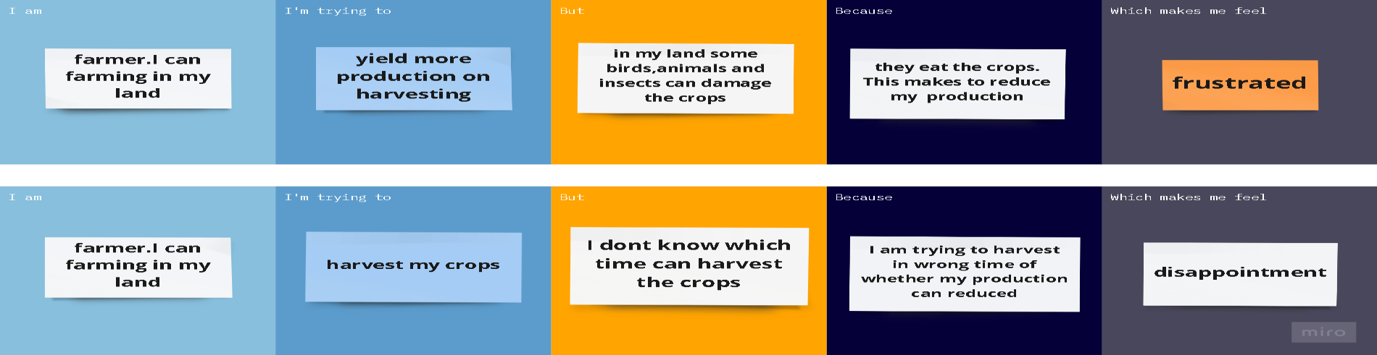

|  |  |  |  |  |  |
| --- | --- | --- | --- | --- | --- |
| **Problem**  **Statement (PS)** | **I am**  **(Customer)** | **I’m trying to** | **But** | **Because** | **Which makes me**  **feel** |
| PS-1 | I’m farmer. I can farming in my land | yield more Production on harvesting | But in my land some birds, animals and inserts can damage the crops | They eat the crops. This makes to reduce my production | Frustrated |
| PS-2 | Framer I can farming in my  land | Harvest my crops | I don’t know which time can harvest the crops | I am trying to harvest in wrong time of whether my production can reduced | Disappointment |

Reference[: https://miro.com/templates/customer-problem-statement/](https://miro.com/templates/customer-problem-statement/)